Using German City Maps

Step 1.
Click on Ancestry.com.

Step 2.
Scroll down to “More Collections and click on Ancestry Card Catalog.

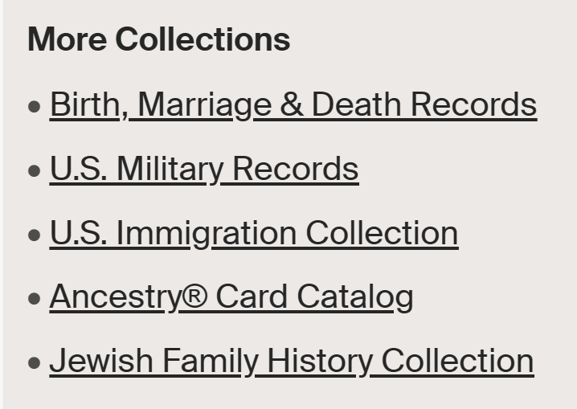

Step 3.
Under “Keyword(s), type Germany gazetteers and click search.

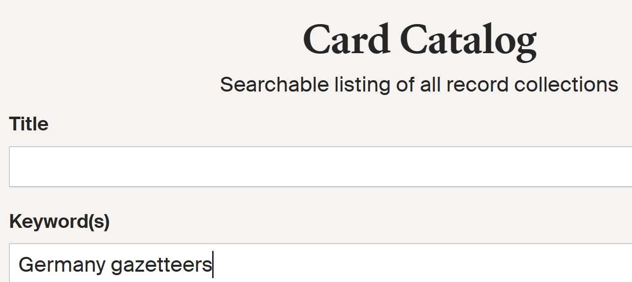

Step 4.
Scroll down to Meyers Gazetteer of the German Empire (in German) and click on it.

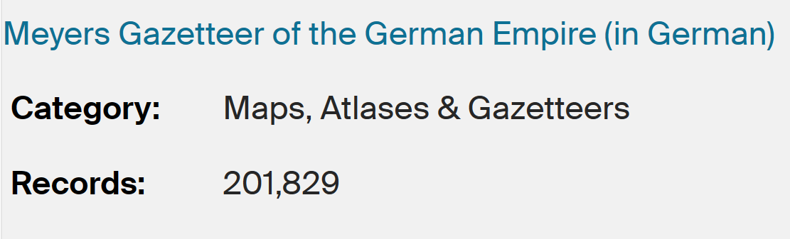

Step 5.
Scroll down to Browse this collection. Under the heading “First Letter of the place name” click in the “choose box” and enter the first letter of the locality name you want to look up.

In the following example, the letter A was entered.

Browse this collection
To browse this image set, select from the options below.
First Letter of the Place Name
Choose.. A

A list of all the German locality names beginning with A will then be listed.
- Aa — Aachen
- Aachen — Abbendorf
- Aachen: Stadtplan und Straßenverzeichnis
- Abbendorf — Aboncourt
- Abracken — Abtsroda

Step 6.
Click on your locality name with a colon (:) and the words “Stadtplan und Strassenverzeichnis” (city map and street index) after it.
In this example I have selected Augsburg: Stadtplan und Strassenverzeichnis..

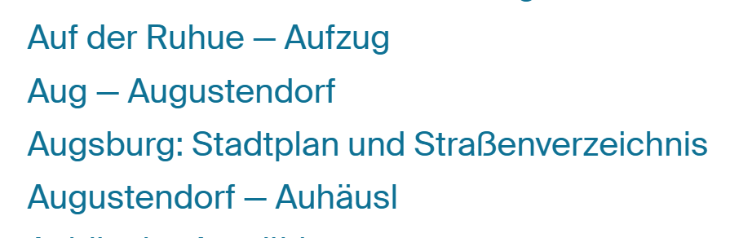

Step 7.
By clicking on this, it brings up the Augsburg city map. The map can be enlarged by clicking on it.

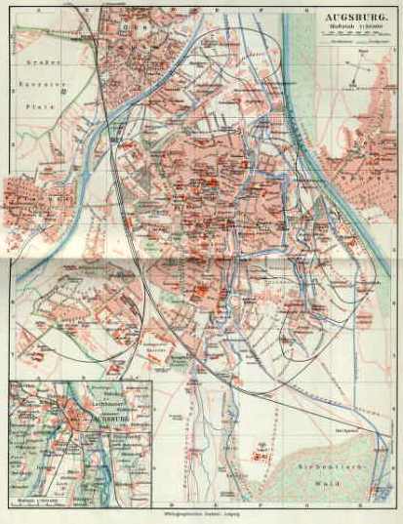

Across the top and bottom of the map, the columns are listed A to H.
On the right and left sides the sections are numbered 1 through 9.

The street index is found on the pages following the map, with the streets listed alphabetically.
Using Otto Street as an example,

Step 8.
Look up the name of the street and copy the street coordinates. In this example, I will look up Otto Street.

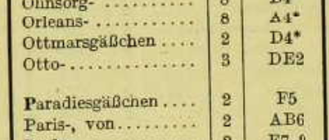

The coordinates for Otto Street are DE2.

Step 9.
On the map, look up the street coordinates to find your street. On the following map, coordinates DE2, shows Otto Street underlined in green.
D
E

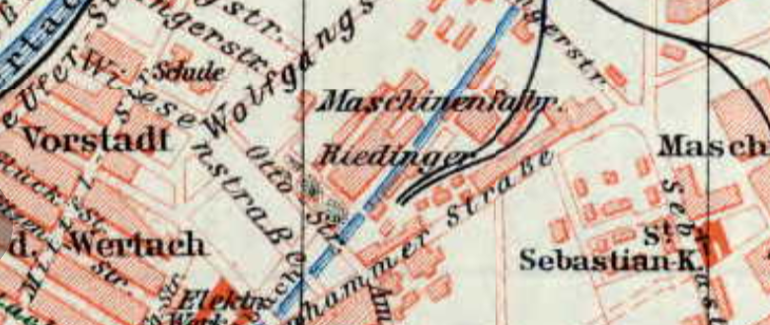
2

Step 10.
From the location of the street, an area search showed that the closest parish on the above map was the St. Sebastian church, highlighted in blue.

The following is an alphabetical list of the fifty cities in the Meyers gazetteer that have a city map. The list identifies the volume the cities are in and the page they are on.

Meyers Orts= und Verkehrs=Lexikon des Deutschen Reichs
List of German City Maps in Meyers Gazetteer

Volume 1
Aachen, Rheinland, Prussia – page 1
Augsburg, Bavaria – page 86
Barmen, Rheinland, Prussia – page 110
Berlin, Brandenburg, Prussia – page 147
Bochum, Westfalen, Prussia – page 194
Braunschweig, Braunschweig – page 227
Bremen, Bremen – page 235
Bremerhaven, Bremen – page 236
Breslau, Schlesien, Prussia – page 238
Cassel, Hessen-Nassau, Prussia – page 289
Charlottenburg, Brandenburg, Prussia – page 291
Chemnitz, Mecklenburg – page 293
Cöln, Rheinland, Prussia – page 300
Crefeld, Rheinland, Prussia – page 300
Danzig, Westpreussen, Prussia – page 319
Dortmund, Westfalen, Prussia – page 368
Dresden, Sachsen (kingdom) – page 375
Duisburg, Rheinland, Prussia – page 381
Düsseldorf, Rheinland, Prussia – page 388
Elberfeld, Rheinland, Prussia – page 423
Erfurt, Sachsen, Prussia – page 447
Essen (Ruhr), Rheinland, Prussia – page 459
Frankfurt a. Main, Hessen-Nassau, Prussia – page 501
Gelsenkirchen, Westfalen, Prussia – page 556
Halle (Saale), Sachsen, Prussia – page 709

Hamborn, Rheinland, Prussia – page 712
Hamburg, Hamburg – page 713
Hannover, Hannover, Prussia – page 720
Karlsruhe, Baden – page 932
Kiel, Schleswig-Holstein, Prussia – page 957
Königsberg. Ostpreussen, Prussia – page1035

Volume 2
Leipzig, Sachsen (kingdom) – page 45
Lübeck, Lübeck – page 103
Ludwigshafen, Baden – page 134
Magdeburg, Sachsen, Prussia – page 123
Mainz, Hessen – page 127
Mannheim, Baden – page 134
Metz, Elsass Lothringen – page 177
Mühlhausen, Elsass Lothringen – page 227
Mühlheim, Rheinland, Prussia (Ruhr) – page 228
München, Bayern – page 230
Münster, Westfalen, Prussia – page 234
Nürnberg, Bayern – page 347
Plauen, Sachsen (kingdom) – page 486
Posen, Posen, Prussia – page 505
Saarbrücken, Rheinland, Prussia – page 660
Stettin, Pommern, Prussia – page 878
Strassburg, Elsass Lothringen – page 893
Stuttgart, Württemberg – page 906
Wiesbaden, Hessen-Nassau, Prussia – page 1142

