For help with your family history call Jane Doe 403-794-2948

For help with your family history call Jane Doe 403-794-2948

There is no better gift to give your ancestors than that they cannot do for themselves, Salvation. Find those who may need temple work by doing Descendancy research. Going out 7 generations on each of your lines and assuming each family had 4 children and coming forward, you could have over 8 million people.

Give the Gift of Salvation!

6- Look for **green boxes** (may need temple work) and **yellow boxes** (incomplete information). Open more posterity by clicking on arrows beside their name. Legend is on top right.

7. To see a short video and get a handout: Google “byufhl Family History Basic Tutorials” Descendancy Research

1-Sign into FamilySearch with your username and password.

2- Click on Fan Chart

3- Choose an ancestor born in the late 1700’s and click on their tree icon

4-When the fan chart comes up on that ancestor, click on the word “Descendancy”

5- Click on “4” generations.

1-Sign into FamilySearch with your username and password.

2- Click on Fan Chart

3- Choose an ancestor born in the late 1700’s and click on their tree icon

4-When the fan chart comes up on that ancestor, click on the word “Descendancy”

5- Click on “4” generations.

6- Look for **green boxes** (may need temple work) and **yellow boxes** (incomplete information). Open more posterity by clicking on arrows beside their name. Legend is on top right.

7. To see a short video and get a handout: Google “byufhl Family History Basic Tutorials” Descendancy Research

There is no better gift to give your ancestors than that they cannot do for themselves, Salvation. Find those who may need temple work by doing Descendancy research. Going out 7 generations on each of your lines and assuming each family had 4 children and coming forward, you could have over 8 million people.

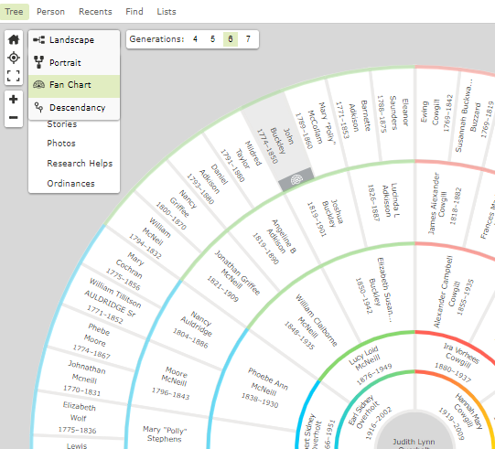

Give the Gift of Salvation!

# Family History Nuggets

# Family History Nuggets