A

Findmypast specializes in English research such as USA, England, Ireland, Scotland, Canada, Australia, and New Zealand. It has the largest collection of Irish records anywhere online. It has over 1,000 exclusive collections not found anywhere else, USA Census records from 1790, newspaper pages dating back to 1710, and new records being added every week.

A-View your tree, create a tree or import a tree. View your tree in different ways.

B-Short cuts to different types of searches

C- Free Records are available to everyone even those without an account.

D-“My Records” are all the sources of all your people in your tree.

E-Blog and Help- find helpful information.

F- Your account & preferences or “l og out”

G- Start a search

H-View hints on this person

I- Watch videos on various aspects of FMP and genealogy.

J-View your tree

K-This part changes often with different focus articles.

L-Go into Quick links to start a search

M-New Records are added every Friday

N-Video on how to get started with FMP

Findmypast.com

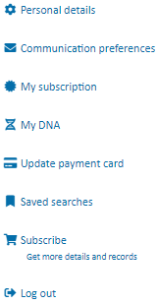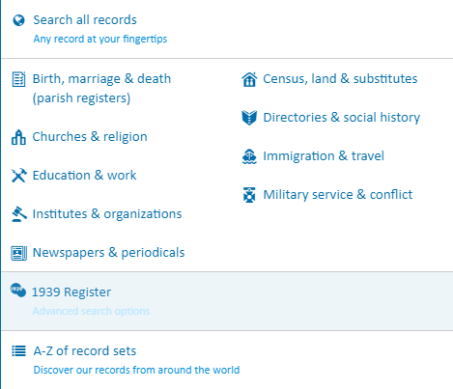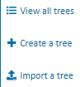

MEANS LOTS OF GOOD LEARNING ARTICLES AND VIDEOS

R

Q

P

O

N

M

L

J

K

I

H

G

F

E

B

D

C

O-Learn about different countries and help on building your tree

P-Learn about using the site-FAQ or contact them

Q-Learn about the company

R-“Connect with us” on social media or read their blog or watch videos on YouTube on how to work in the program.

Above you get a summary box when you click under a name. See their tree, go to their profile page, edit information, add a relative, start a search or go to their hints

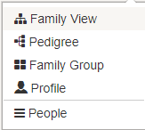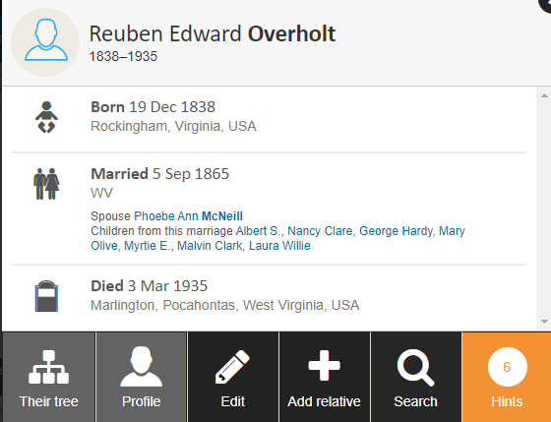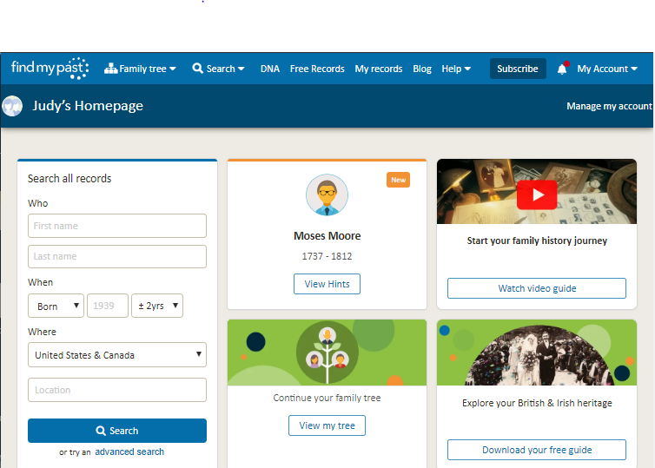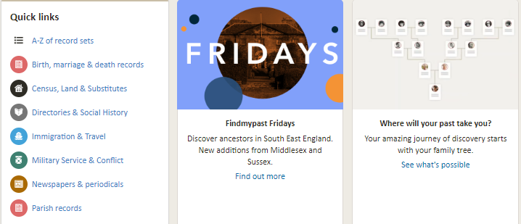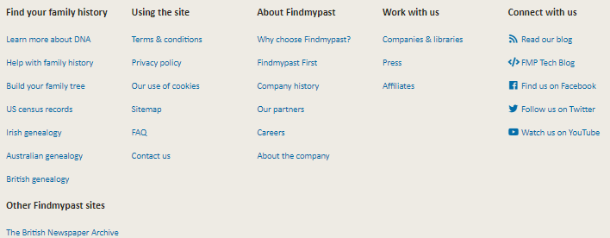

Google “byufhl family history basic tutorials” to see a video on this plus others. Also “Classes and Webinars” takes you to more learning videos.

Judy Sharp Updated January 2020

Profile Page

See Profile page in different views: Overview, Facts & Events, Media, Notes and Hints. In this same section you can edit (pencil beside their name), View them in tree (under their birth ) or remove the person. You can do a general search for more records here.

Attaching a Hint

1-Click on “Review” a **hint**. If it applies to your ancestor, click “Yes, Next step” If you click on “Maybe?”, this record will go into a file here to view later.

**2**-Compare your tree information to the record. Bring over any information that is better by clicking on arrows between the records. “Save changes to tree”

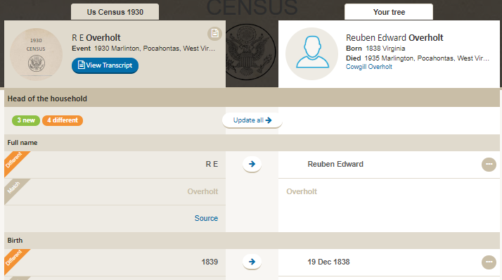

**General Search**

**A-** Start by **choosing a country**

**B**-Can search **all categories** or filter down to these filters.

**C**- Filter by a **subcategory** (see drop down for choices)

D-Can filter by a **Record Set** (see drop down for choices)

**E**-“**Useful links and Resources**” can be helpful also.

**F**- Click on the **Help** tap to bring up bubbles of information showing you how, where and what to put in the search fields.

<https://i.findmypast.com/websites/content/pdfs/your-must-have-guide-to-finding-british-and-irish-ancestors.pdf> for free booklet download on how to use category, subcategory and record sets.

Other useful websites for UK research are: 1-irishgenealogy.ie/en 2-irishfamilyhistorycentre.com 3-ffhs.org.uk 4-nationalarchives.ie 5-one-name.org 6-irishlivesremembered.ie 7-www.sog.org.uk 8-facebook.com/findmypast 9-scotlandspeople.gov.uk 10-nationalarchives.gov.uk



B

F

E

D

C

A

