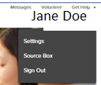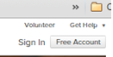

Go to familysearch.org to register for a free account. Fill out the boxes.

Anyone 13 and over can get a free account. Children 8-12 can get an

account with their parent’s permission. If you are a member of the

Church of Jesus Christ of Latter Day Saints, your membership number can be obtained from the ward clerk, back of your temple recommend, or on your phone under “LDS TOOLS” app. They will send you email confirmation, and then you are ready to start. You will then want to go into your settings located under your name and go into the 5 tabs below.

Caution: do not share email addresses. Create your own unique

email. This can create problems. Go to the “Get Help” top right and

type in “What are the rules for my username and password?

Go to the bottom of a page and click on “English” and choose

your desired language from the pop-up. In the “Get Help” type in

“How do I enter names in Family Tree that are a different language?

if you need to type in a name that is in a language other than your own.



# FamilySearch Registration and Settings

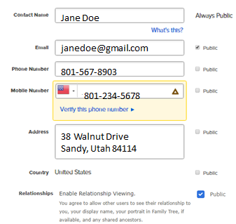

CONTACT- You can make any of this information public or private. Your email should be **public** so anyone wanting to collaborate with you on your family tree will be able to get hold of you. Put in your mobile phone number if you would like FamilySearch to text you should you forget your password. “Enable Relationship Viewing” allows others to see their relationship to you when you put a check mark beside it.

ACCOUNT - You will need to sign up with a Username and Password which you will sign in with every time you go into FamilySearch. Change it here if you desire. You can see your membership number. The “Helper Number” is what you give someone if you want them to get into your tree and possibly make changes. Or you would get someone else’s Helper Number if you are helping them. Go to the top right of your details screen click on “Help Others”.

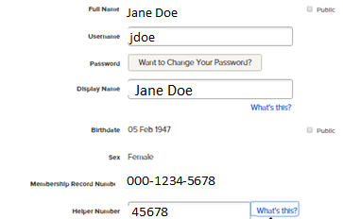

Click on “off” if you don’t want to see any notifications

Judy Sharp- Updated November 2019

Google “byufhl classes and webinars” to see class schedules & online videos and handouts.

CONNECTED ACCOUNTS- If I see anything here, it means I am connected to these accounts. I have registered for these and I have a password. If I can’t remember my password, I go into that account and say “forgot password” and they will allow me to reset it. If I see nothing here, it means I am not connected to any partner sites and I can sign up for them. The person on the left is signed up for 3 partner sites. Click “Revoke Access” if you no longer want to use a site.

PREFERENCES- put a check mark by “Show LDS Temple Information” if you want to see LDS ordinances. Uncheck if you do not want LDS ordinances to show.

You can choose to start with another person in your tree if you didn’t want it to be you.

You can choose what language you want for email notifications.

NOTIFICATIONS**- there are many notifications you can get by putting a check mark beside the ones you want. I would advise checking all of them. You can get notified when a FS message comes in, allow consultants to help you, allow others to share temple opportunities with you, see what is new in FS, see inspiring stories and experiences focused on family history, dates of Roots Tech conference, and resources to help you with Family Hx.**

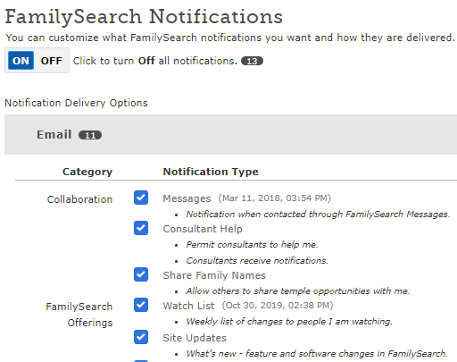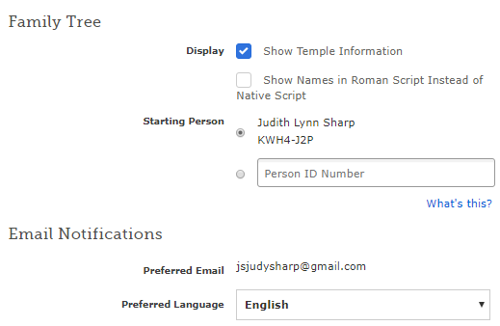

NOTIFICATIONS put a check mark here if you want to receive email notifications when another user contacts you through FamilySearch messaging.

Check mark the boxes that you want to receive notifications on. It is a good idea to check them all so you can keep up on the FT announcements, or changes made to your tree by others, etc.

