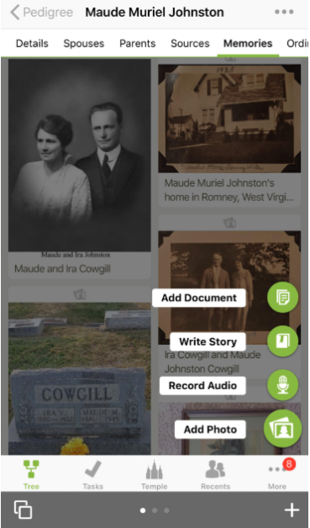

+



IPhone- To add a memory, Go into person detail page, and tap on Memories, then tap on the green circle with plus sign to open up these options.

To add **photos and documents** touch icon beside the word, select from your cameral roll or take a picture. Use picture or retake it. Crop or rotate it if needed. Save it. May add a 5 minute audio to the picture by tapping on the microphone. To attach other people in the photo, tap on person icon bottom right, move the circle to the head. Tap on add name and choose from the list that comes up. Then tap done.

Touch on **Audio**, tap” begin recording”, tap on “start”, keep it under 15 minutes. Tap “done”, give it a title, save it.

Tap on **Story** icon, type in story or touch microphone on keyboard and dictate it.

( FamilySearch gives you an hour to type in a story. If need more time, save it, and go back in and EDIT it to finish. Give it a title and save it. To add a story to other people’s memories, touch people icon at bottom right of screen to bring up a list of people from your tree and tap on their name.

Using the Family Tree Mobile App

1

2

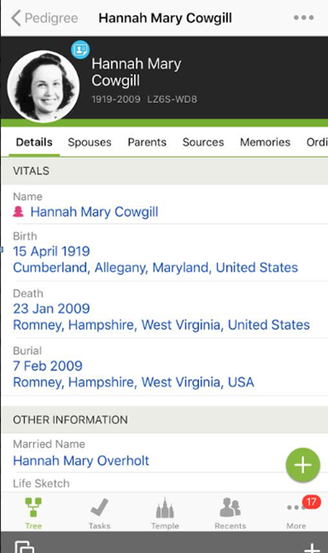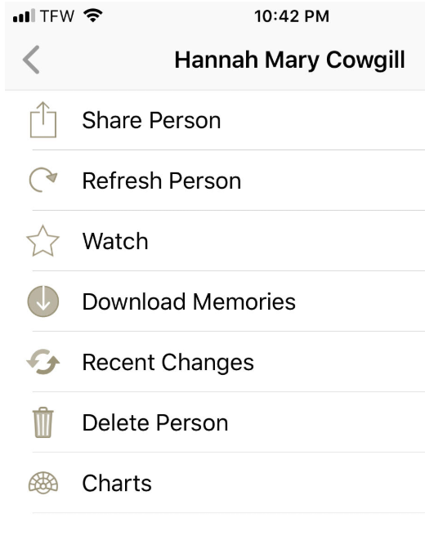

1

2

IPhone-

Touch 3 dots **bottom right** of screen to Search Historical Records, Find a person, see Relatives Around Me, Map My Ancestors, Family History Activities, see Messages, Settings, Get help (help others, see what is new, contact support, or type in a question to see an article) get Memory app or Other apps, or Sign Out.

IPhone- - Touch 3 **dots top right** of the screen **while on details page** to bring up top left two screens. (View relationship, Search Records, Duplicates, Descendants with tasks, View this Tree)

Touch” More” to bring up screen just under top one, Share Person, Refresh Person, Watch, Download Memories, see Recent Changes, Delete the Person or see and print out Charts.

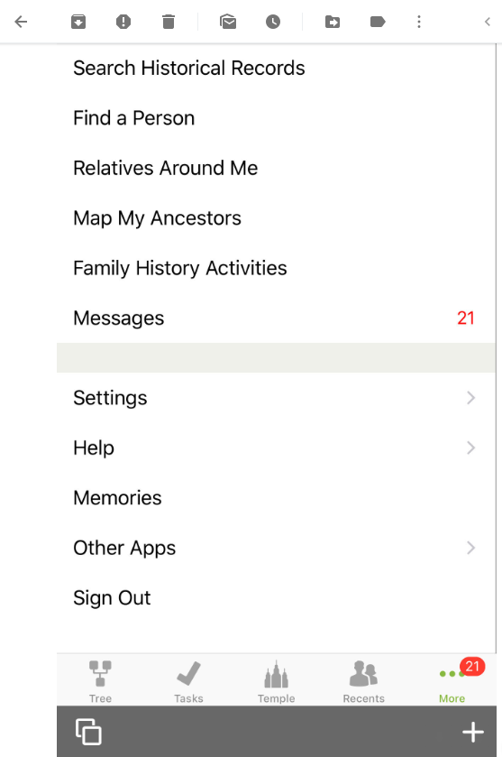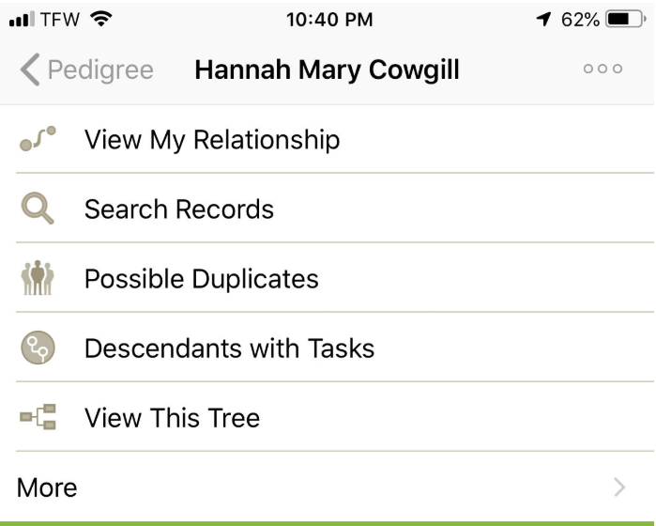

**. . .**

IPhone- Under Settings you can enable **Temple Ordinances , Show Maps in Find, Enable Relationship Viewing** (allows other contributors to see how they are related to you), **Enable Multiple Screens, or download offline Pedigree.**

Just above the white dots, touch on **Tree** icon to go back to your tree; **Check Mark** (Tasks) will bring up people with hints or ready for the temple; the **Temple** icon will open your reservation list or temple ready the **Recents** (People) icon gives a list of the last 50 people you visited.

Tapping on bottom left allows you to thumb through the different open pages by swiping sideways; the plus sign bottom right allows you to add more pages. The four dots at the bottom tell you that you have 4 pages open.

**…**

. . . .

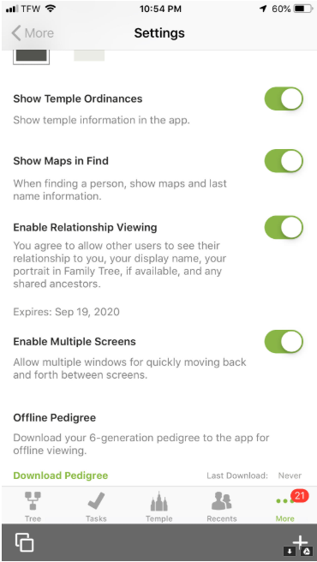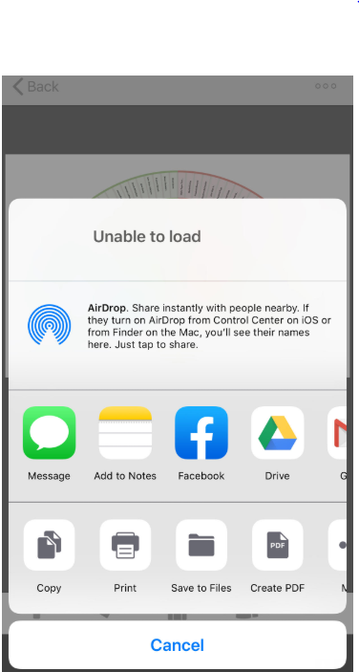

IPhone To print to a wireless printer, tap on the desired chart or temple card to bring it to the forefront, tap on the 3 dots top right of screen, then tap on the word “share”.

(If you want to print out temple cards and you are not by a wireless printer, a number will come up. Show that number to the temple workers and they can print out the cards)

Tap on the word “print” It will ask you which printer if you have more than one. Just follow the prompts on the screen.

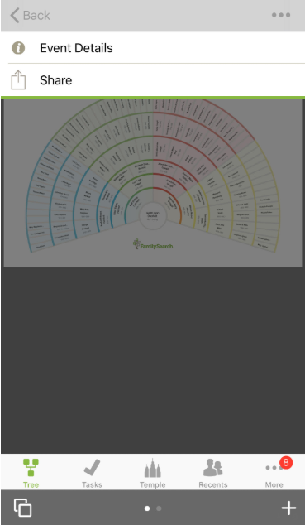

….

….….

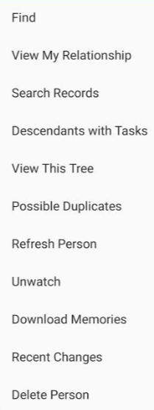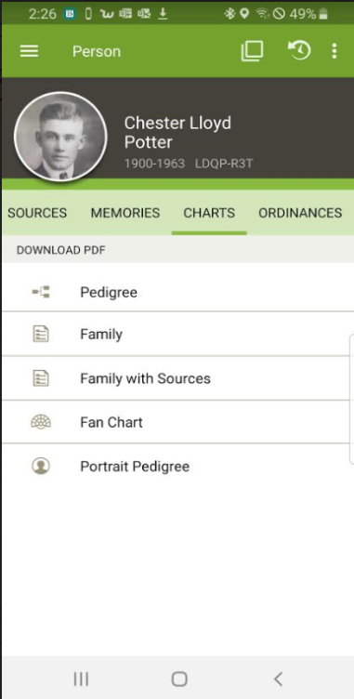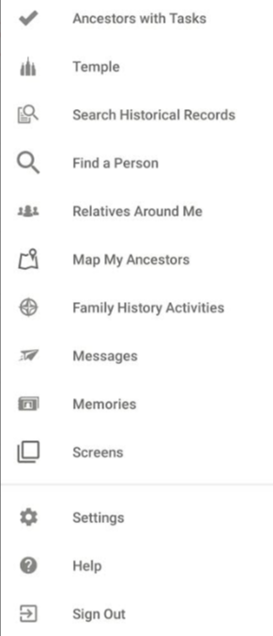

Android Phone-

Touch three lines **top left** of your screen to bring up this menu seen on the left. Pedigree, Ancestors with Tasks, Temple List, Search Historical Records, Find a Person, Relatives Around Me, Map My Ancestors, FH Activities, Messages, Memories, Screens, Settings, Help, Sign out. Tap on the word temple to see and print names to take to the temple from your list or it will give you the choice to tap on “Temple Ready”. Touch here to see last 50 people visited

6

1

2

3

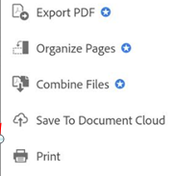

7

5

4

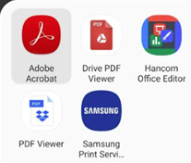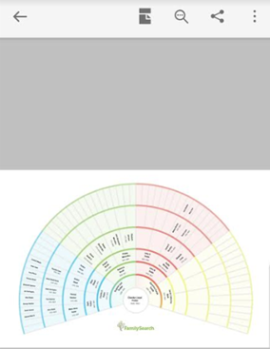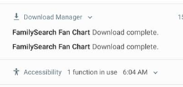

Android phone:

To print. 1- tap on desired chart, 2- Tap download PDF 3-top of page-swipe down by white arrow 4- tap on chart to be opened

5- On next screen open with Adobe Acrobat 6-On Next Screen tap on 3 dots top right of the screen 7-to bring up print function and tap Print.

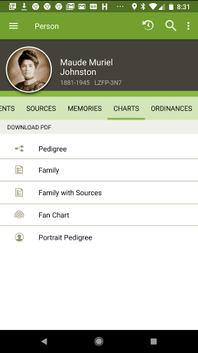

Android Phone- Tap on three **dots top right** while in the details page to bring up Find, View My Relationship, Search Record, Descendants with Tasks, View this Tree, Possible Duplicates, Refresh Person, Watch, Download Memories, Recent Changes, or Delete Person.

Touching the white arrow, top left, shows something has been downloaded.



Judy Sharp Updated Sept 2019