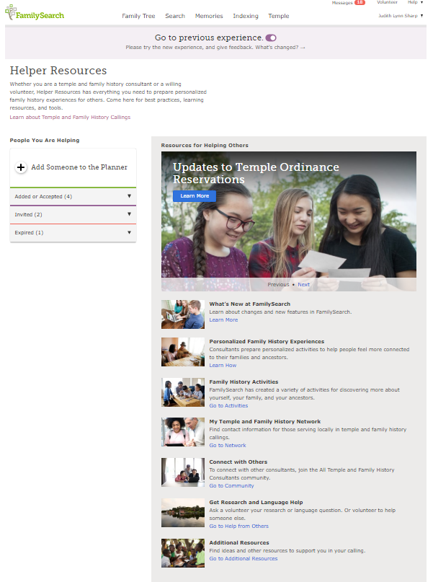

Learn about your calling as a Stake or Ward Temple and Family History Consultant

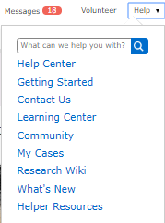

FamilySearch Consultant Planner

1. Ask someone if they would like help with their family history.
2. Ask if they would give you permission to view their tree so you can help them better. If they say yes, tell them to look for your email and respond to it
3. Go into FamilySearch and click on “Invite” send them an email. A list of stake and ward members come up for you to choose from. Or you can go in immediately by asking for their user name and helper number (found under Accounts under settings, under their name.)

4. After a little while their name will appear in the box that says “Added or accepted”. Then you click on their name and go into to their tree. You can also show them all the fun things their tree can tell about them on the back of this handout.

7

**Family History Activities**- FamilySearch has created a variety of activities for discovering more about yourself, your family, and your ancestors.

**My Temple and Family History Network-** Find contact information for those serving locally in temple and family history callings.

**Connect with Others**- Connect with other consultants; join the All Temple and Family History Consultants community

**Get Research and Language Help**- Ask a volunteer your research or language question. Or volunteer to help someone else.

**Additional Resources**- Find ideas and other resources to support you in your calling. Download PowerPoints, and videos to teach, motivate and inspire. Learn how to work in the FS Tree and Indexing. Find all the church policies in one place relating to temple work. See the latest consultant news, and find resources to help you operate a family history center.

6

5

4

3

1

2

**What’s New at FamilySearch?** Learn about changes and new features in FamilySearch

**Personalized Family History Experiences** -Consultants prepare personalized activities to help people feel more connected to their families and ancestors.

2

2

7

6

5

4

3

1

Under the HELP menu, choose Helper Resources

Updated October 2019

Google “byufhl Family History Basic Tutorials” for a video on the Consultant Planner.

Judy Sharp

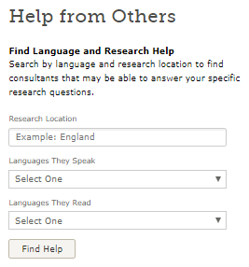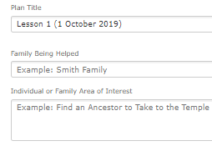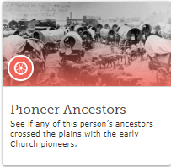

Once you click on a person you are helping, you will see a menu with 5 different categories Discovery Ideas, Tree, Notes, Plans, Help from Others.

Discovery Ideas- 3 subcategories: Family History Ideas – takes you to places they can see their ancestors in Pioneers, Headstones, Draft records, Joseph Smith Papers etc. Hints- show people in their tree that have hints to attach to their tree. Temple- will show people in their tree whose information is incomplete, or who might need temple work done and those who have duplicates.

Tree- shows their fan chart with all the different categories.

Notes- Allows you to create a note for future reference.

Plans-You can create a lesson plan for this person which can include goals or resources. Under Actions , (top left) you can print out that plan, or delete it or download it or Open Plan Titles.

Help from Others- allows you to search by language and research location to find consultants that may be able to answer your specific research questions.

This green bar will be present at the top of the page so you remember that you are helping someone. Click on the ‘x’ to stop helping.

