GEnealogical Data COMmunication- is a way to exchange Genealogical information between software programs

# GEDCOM BASICS

**FamilySearch** does not support GEDCOMS. But FamilySearch **links** to Ancestry. Ancestry can transport **four generations** at a time from FamilySearch into Ancestry. **Both programs can exchange information, including sources, back and forth with each other.** They cannot as yet transport pictures. **Ancestry is a good place to start your tree** if you don’t have one. The reason is because **no one can change information** in your tree without your permission, it can **link with FamilySearch**, the program will **find hints and sources** for you, and you can **GEDCOM it into other data bases.** FamilySearch can **exchange information** between Legacy, Roots Magic and Ancestral Quest. MyHeritage can now bring over 8 generations from FamilySearch. If you already have a tree in MyHeritage it puts it in a different tree. If you change information in either your new MyHeritage tree or FamilySearch Tree, you can go in often and synchronize the two. This is in Beta form now; more functions will be coming in the future.

To IMPORT and EXPORT a tree, go to the program where your tree is, and create a GEDCOM to EXPORT. Once this tree is exported, you can transport it to as many data bases as you like. To bring a tree into a data base, go to the program you want to bring your tree into and click IMPORT. The programs walk you through the steps. If you have the chance to link 2 programs, that is the preferred way.

Ancestry, MyHeritage, Findmypast, PAF, RootsMagic, Legacy, AncestralQuest **can GEDCOM genealogical data between each other.** **Ancestry, MyHeritage, and FindmyPast are partners with FamilySearch**. Members of the Church of Jesus Christ of Latter Day Saints can get **a free account for all 3 of these**. PAF is an older program people used before computers came into wide use. It is not supported anymore but you can convert all your data over into AncestralQuest directly without a GEDCOM. **Roots Magic, Legacy, AncestralQuest** are **free to be downloaded.** They are private data bases no one can change information in them except for you. Or if you want more functions, you can upgrade each for about $20. Prices, however, will be going up as they create more and better functions.

GEDCOMS transfer **data only**. They **do not transfer Media**. Exceptions are: **MacKiev** will transport data and pictures from Ancestry (About $29-$90/year**. Family Tree Builder** will transport data and pictures from MyHeritage. Pictures will go in a separate file. It is FREE

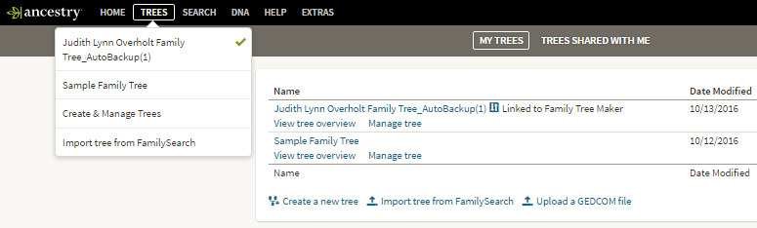

5

## MyHeritage

Go to “Manage Trees” to Export

Click on “Export to GEDCOM” by tree. Follow the prompts .Save it to a file.

Click here to Import a tree

It will walk you through the steps

3

8

7

Ancestry : to E To Export: go to “Create and Manage Trees”. On the next screen, click under “Manage tree” beside the tree you want to export. After it downloads, name it and save it to a file.

To Import a tree into Ancestry click on “Upload a GEDCOM file” here

It will walk you through the steps.

2

6

## Findmypast

To Export: Under “Family Tree” top toolbar, click on “View all trees” then beside the tree to export, click on this icon to download. Save it to a file.

To import: click here and it will will walk you thru the steps.

.

Judy Sharp Updated 2019

8

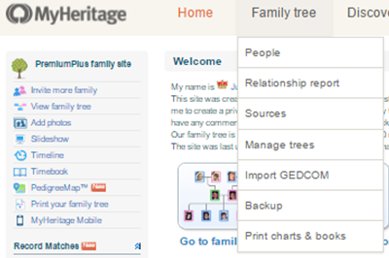

4

3

3

7

6

4

5

2

1

1

1

1

