Searching (Records, Family Tree, Genealogies, Catalog, Books, Wiki) in FamilySearch

## Search for a name under Records

**In searching for a NAME, you may try using wildcards such as a ? in place of one letter or an asterisk to replace several letters. (must have at least 3 letters: Joh* will work , Jo* will not work)**

Search by an “EVENT” such as birth, marriage, residence, death (Can try giving a 2, 5, or 10 year span)

**Search by a “RELATIONSHIP” such as spouse, parents. Try just entering the parents when looking for children. Or you might look for the children’s death records if you’re trying to find the mother’s maiden name or child’s spouse. Death dates will have more information on them. Marriage records can be good too if they list both the parents’ names.**

“FILTER BY COLLECTIONS”: click on this to open all the collections. Maybe I want to see only tax collections or an obituary index. They are adding to this collection frequently and you can see at the top of the column when it was updated.

**“BROWSE IMAGE” -Image only means that the record is in its original form –not indexed. Images have been grouped often by localities or year range instead of by a person’s name. There are hundreds and millions of records under each data base.**

## Search the Catalog

**The catalog is a collection of films, books or fiche from various libraries. Only about 7% of all the genealogies we know about are online. The rest will be found in books and films. Online information is growing daily but if you can’t find it online, you may want to go to the catalog, especially if you are searching in the 1700’s and earlier. You can search by place, last names, titles, author, subjects or keywords. FamilySearch catalog also includes a link to WorldCat which is the largest network of library content and services in the world and can be accessed through your computer. ArchiveGrid and can also be accessed through your computer. Click on WorldCat and ArchiveGrid to learn how to use it. Put in a place in the search bar (narrow by county if desired) and chose from the many databases. Going into a data base, it will tell you where to find a book or film and if it is available. Most things will be at the downtown FH library or BYU FHL. They do not send out films to local FH centers anymore. They are digitizing all records to go online.**

## Search by Genealogies

Genealogies are records from the old ancestral files and pedigree resource files. They are records people turned in before the computer age. Insert what information you know on your ancestor and click search. Perhaps someone else has more information on that ancestor. You can’t use this information as a source, but it may give you the names you need to know to go and find official sources in which you can verify them. Some may have sources attached to their file.

#### Book

Catalog continued…after you choose a **data base**, click on the name to open it. It will tell you where the information is. Above are some examples of where that database is found. It might already be online and you can click on the link to see it. If it is book form, it will tell you the call number and location of the book and if it is available If it is on a film, it will give you the location, film number and you will see the film icon. Clicking on “Family History Library” will tell you their hours and location.

##### Film

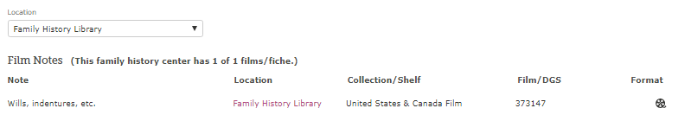

3

### Online

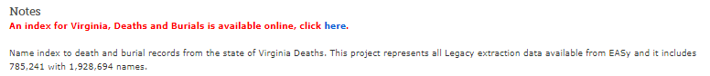

2

1

1

1

2

3

**Search Family Tree**

**Tree**: 4 ways to display your tree. **Person**: takes you to your person page. **Recents**: last 50 people you visited in your tree. **Find**: by name or PIN. **Lists**: list of people you are watching (click on “watch” to say “unwatch”) FS will notify you of changes made by others.

# **Search for Books**

FamilySearch has more than 440,000 digitized family history books and publications. Books can contain family histories, genealogies and all kinds of stories and hints to find your ancestors. Try inserting your surname (Or place or event) of one of your ancestors into the search bar and see all the books that may contain that name. Make your access “Public” to narrow your search. Click on “full text results” to see the excerpts from the book that has your surname in it. If you want to know more, click on “view” under the one you want to see and it will take you to the actual page in the book. On the tool bar at the bottom of the page , hoover your mouse over the icons to see the book in different views.

Judy Sharp Updated Sept.2019

# **Search the Wiki**

Wiki is like Wikipedia only better. Here instead of searching for people by name, you search by a place. Boundaries and places have changed over the years. The place you are looking for may not have existed when your ancestor lived. Wiki gives you all kinds of information on types of searches, strategies and research tools. Anything in blue type is a direct link to that site. There are hundreds of places to search. Every place on earth kept records a little differently, so this a great tool for finding your ancestors.

Judy Sharp 2016