Ancestry provides access to 20 billion searchable historical records(adds an average of 2 million records daily, some going back to the 13th century), more than 80 million member created family trees, over 300 million photos, documents and stories, and 15 million DNA samples. Their focus is on the USA and hosts records from 80 countries worldwide.

Ancestry.com

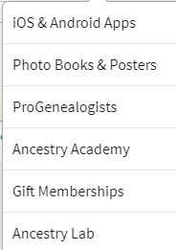

11

100

4

9

8

7

2

1

6

5

3

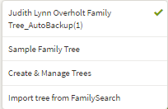

My family Tree

Anyone visiting a Family History library can use the program for free. Members of the Church of Jesus Christ of Latter Day Saints can get a free account. Do this (once only) by signing into [www.familysearch.org](http://www.familysearch.org)/partneraccess and sign in with your LDS account. Click the button **“Create FREE Ancestry Account“** to register and create your free LDS Account. You will log in with the user name and password that you choose each time you access Ancestry.com. If you are between 13-17 years old, you can get your own ancestry account with your parents’ permission and email.

Store the “maybes” here till you decide

**1**-See your tree **2**- Create and manage trees, **3**- Import a tree from FamilySearch **4**-Search all collections or filter by data bases, or go to the card catalog to get more filters on searching **5**-Get help with ancestry in their Support Center, or ask the community or send messages thru their message boards, **6**-Learn about apps, make books and posters or visit the Ancestry Academy for learning videos on genealogy. **Below on the home page**, **7**- make a to do list, **8**-go to quick link or make your own **9**- Go to products and services,**10**-Store information in your Shoebox to consider later **11**- See new records recently added to ancestry.

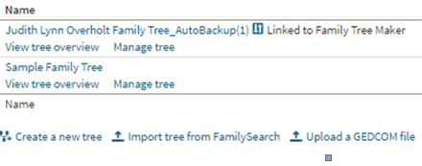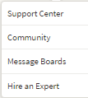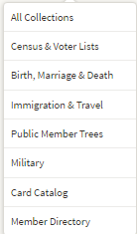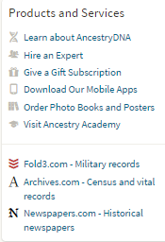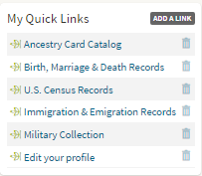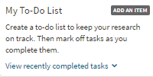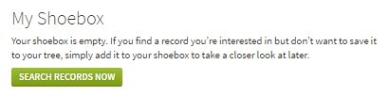

SEARCH

Judy Sharp Updated 2019

Updated 2020 2016

Click under their name on your tree to bring up a 1- SUMMARY BOX, **2**-Go their PROFILE, START A SEARCH, do a QUICK EDIT or under TOOLS (View in Family Tree, Add Relative, Add Tag, or Delete Person) **3**- See their HINTS

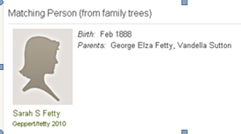

**1**-See different views on LIFESTORY, FACTS, GALLERY (photos) or HINTS **2**-CONNECT WITH FAMILYSEARCH, do a **SEARCH**, **TOOLS** (View in Tree, View Notes, View Comments, Merge with Duplicate, Save to Tree, Print or Member Connect) or **EDIT** (Quick Edit, Edit Relationships, Delete Person) **3**- ADD (Family Events, Alternate Facts or Historical Insights) **4**-ADD (Source or Web Link) **5**- ADD (a Family Member)

5

4

1

2

3

3

4

5

2

1

3

2

1

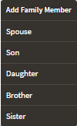

7

6

5

4

3

2

1

Search

On the home page you can  **1**- VIEW PEOPLE WITH HINTS (Attach all the stories and photos, see recent hints at the top of page or look for end of line ancestors) and you can **2**-ATTACH with one click of mouse **OR** on summary box or profile page click REVIEW beside the source and then click **3**- YES and it gives you a chance to **4**-EDIT or bring over information **5**- and SAVE to your tree.

Summary Box & Profile Page

**1**-Do a general search **2**-Adjust sliders for broad or exact searches and click update, **3**-Edit search **4**- make sure all 4 boxes are checked for Stories, Family Trees and Photos in addition to Historical records, **5**-Click on a state to search for records within that state.**6**-Click a family tree with your ancestor in it, (good way to get information if you don’t have much. Sources often included) **7**- click on “**See** **more like this**” to see more trees with your ancestor.

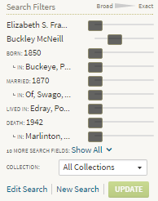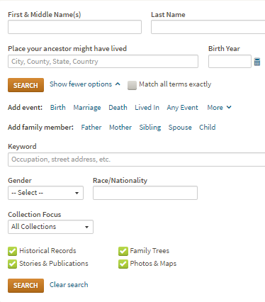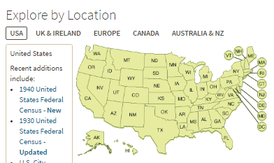

See Hints and Enter Sources & Media

