Family History Nuggets

NEW! Great News! FamilySearch now finds similar records!!

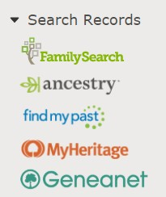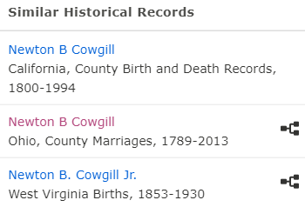Say you are on a person’s detail page and you want to find a record for an ancestor on FamilySearch. Click here and when you look at the list, you see one that might be right. Open the record up by clicking on it and at the bottom right, you will see other records that are similar— other records that you don’t have to go searching for that may help identify your ancestor. Records you may not have thought of.

This is a huge re- search help. This is cause to celebrate ! Bring on the cake!
The tree icon on the right of the record will show what tree this record is attached. It may be attached to the person you are working on. It is good to look at these as they can lead you to people who have this record at- tached indicating a dupli- cate person that may need to be merged with yours.

For help with your family history or questions call Jane Doe (Ward History consultant) at 801-867-9365. If you would like to receive these FH Nuggets through email, send a request to janedoe@gmail.com

This is a huge re-

Family History Nuggets

NEW! Great News! FamilySearch now finds similar records!!

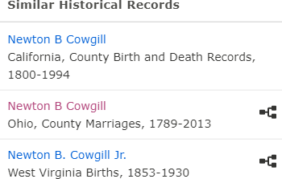Say you are on a person’s detail page and you want to find a record for an ancestor on FamilySearch. Click here and when you look at the list, you see one that might be right. Open the record up by clicking on it and at the bottom right, you will see other records that are similar— other records that you don’t have to go searching for that may help identify your ancestor. Records you may not have thought of.
The tree icon on the right of the record will show what tree this record is attached. It may be attached to the person you are working on. It is good to look at these as

search help. This is
cause to celebrate ! Bring on the cake!
they can lead you to people who have this record at- tached indicating a dupli- cate person that may need to be merged with yours.

For help with your family history or questions call Jane Doe (Ward History consultant) at 801-867-9365. If you would like to receive these FH Nuggets through email, send a request to janedoe@gmail.com

