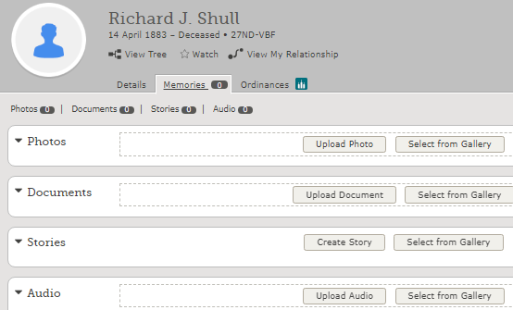

Go to memories on detail page. Upload a photo, document or an audio file. Follow steps 3-6 on the back of this handout. To Tag photos to someone else, click on the image or the red exclamation mark, adjust the circle and name it and save it. You can change a document to a photo and vice versa: on **left** top side of your picture is a drop down under the word Actions- it does all the things listed on right: Open in new tab, Rotate left or right, Download it, Add it to Album , Change to Document or Show Containing Albums. “Move to My Archive” makes it private (only you see it). Deleting a picture or document here deletes it from your whole tree. You can add an audio recording to any photo from your computer or smart phone.

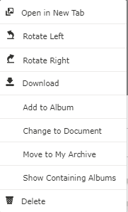

Actions

Adding Memories in FamilySearch Tree

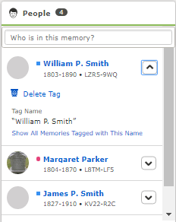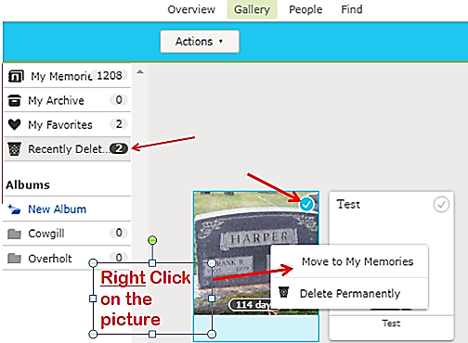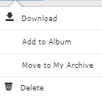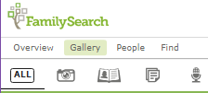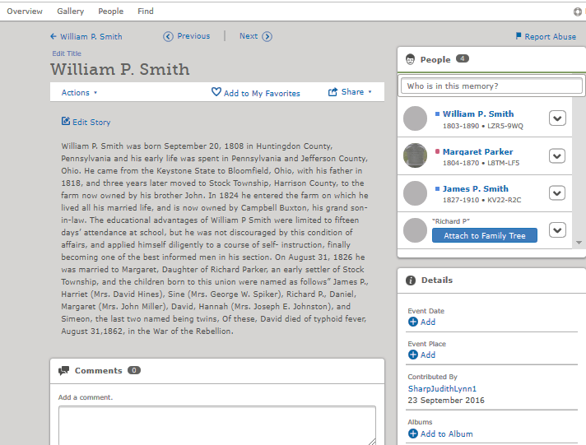

Top Headings in Memories: Overview –is just an overview. Gallery- shows all your memories (pictures, documents, stories, and audio recordings) in picture or grid form. You can sort memories into albums; archive (makes it private) put them in a favorites list or restore a deleted memory. People-another way to filter by name, or birth year, added by you, not attached to the tree. Magnifying glass- searches for a particular name (put in first OR last name OR exactly like it is found in FT). In any of these headings you can sort by pictures, stories, documents or audio recordings or see all of them at once.

To Restore a deleted memory: Go to “Gallery”, click on “Recently Deleted”. It will stay here for 120 days until it is permanently taken off. Left click on the memory you want restored, then right click on the same memory. A box will pop up and you can then “Move to My Memories” and attach it to the right person or you can “Delete it Permanently”

To add a portrait: click on the circle then when all the pictures come up, click on the preferred one. Or you can choose from the gallery or upload a new picture. Click on it again to edit or change.

To add a STORY- type it in or copy and paste it. FamilySearch gives you 60 minutes to type in a story. If not done, click on “save” and go back in by clicking on the story, and click on Edit to finish typing. Give it a title then Save it. Add this story or document to others mentioned by typing in their name in box “Who is in this memory?” Attach it to their tree by inserting their PIN so you know it is attached to the right person.

“Delete tag” deletes this story just from this person. It will still be in your gallery. Add an event date and place if desired or to an album. You cannot delete or edit if someone else put it in. You can comment below the story. Or you can put your cursor under the contributor to see their email and contact them or contact Family Search if there is a problem getting hold of that person. Under “Actions” you can download it, add it to an Album, Move to your archive or delete it. Deleting under “Actions” removes it from the whole tree.

Actions

## A

Put in a title and save it.

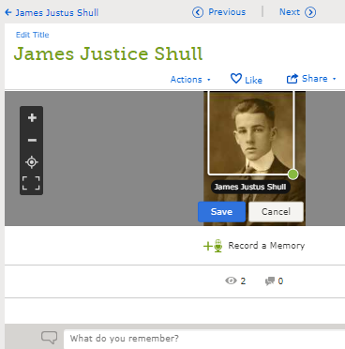

To center and tag this person, click on the red exclamation mark.

5- The picture comes into your memories. To add a picture to the portrait, click inside the circle and you can choose from this person’s memories, upload a new one or choose from the gallery. Click on circle again to change or edit.

6- Click between the eyes and adjust the rectangle to the desired place.

2- In the next box that comes up, go to “file” (top left corner) and do a “save as”. Give the picture a name and save it to your browser or desktop. (Note: you can also “right click” on a picture and do a “save as” without snipping it)

Then click on “Save”

44

Judy Sharp Updated July 2019

5-

3-

1-

**4**-

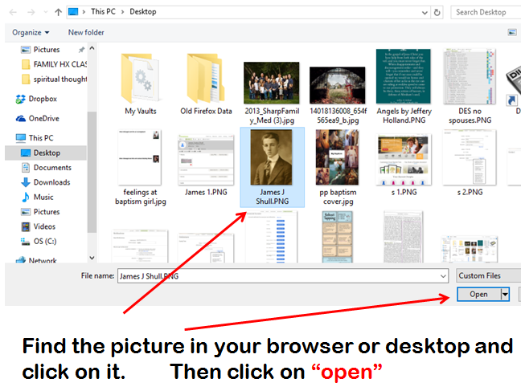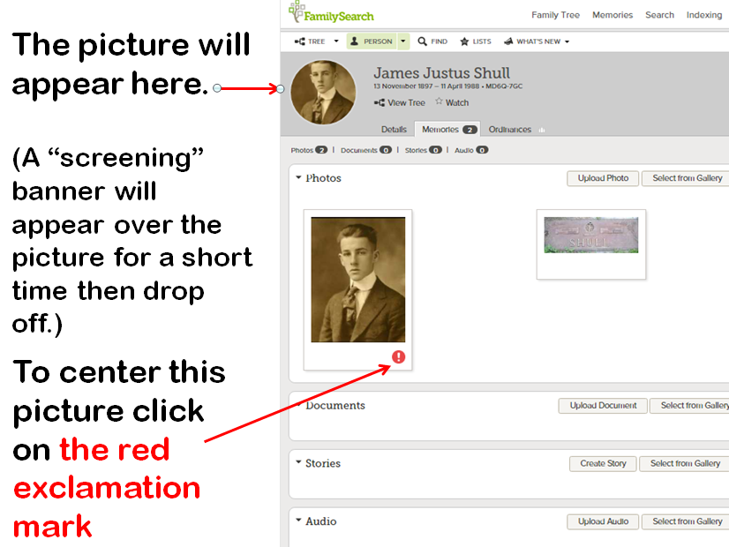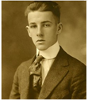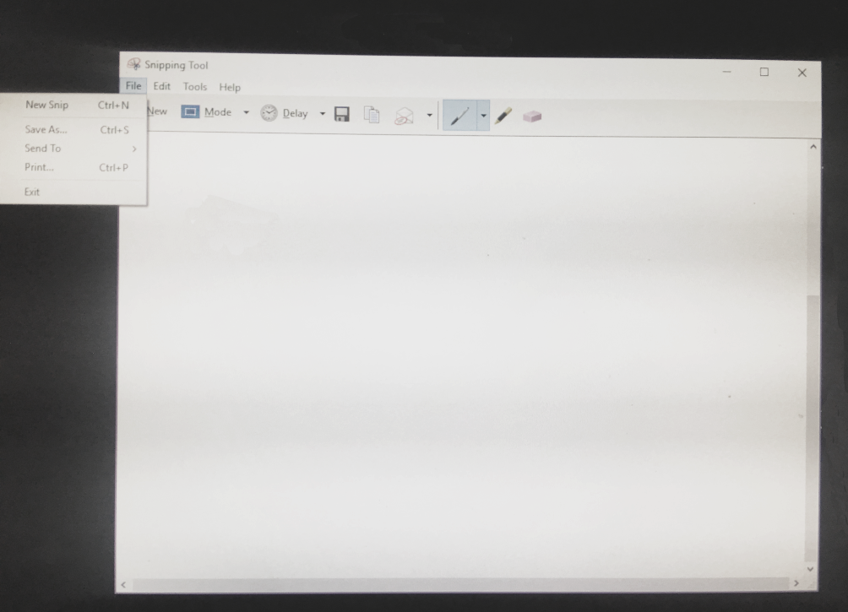

3

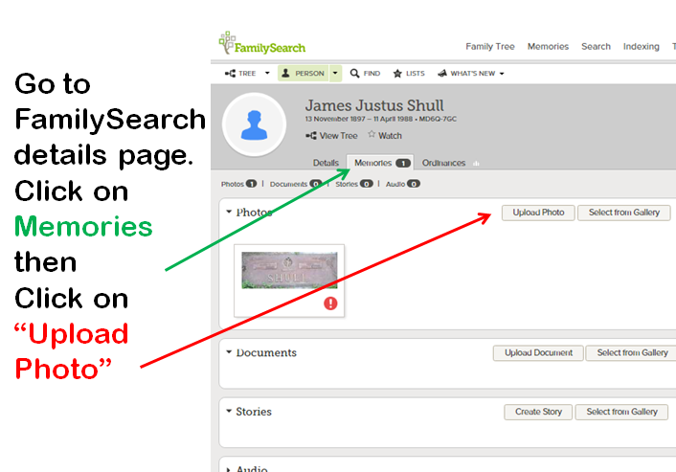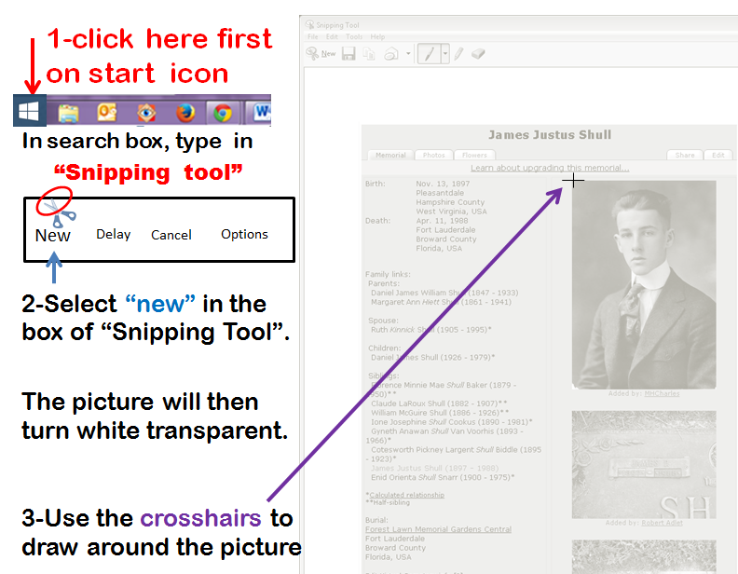

Inserting Pictures into FamilySearch Memories and “Snipping Tool”