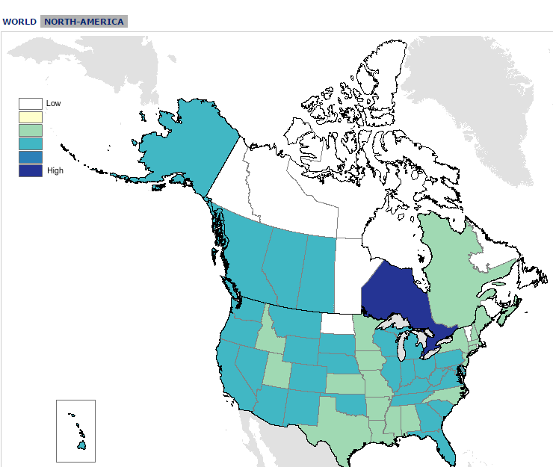

Want to have some fun? Publicprofiler holds names for about 300 million people in 26 countries of the world. You can see where the majority of your ancestors lived.

Google publicprofiler.org

Type in a surname of one your ancestral lines.

The darker your color of blue, the likelihood of high concentration of people with same surname living there.

Click the country to see specific areas.

Or you can chose to search a specific country- you will see the Top Forenames and the Top Surnames

Or you can do an Ethnicity search



Want to have some fun? Publicprofiler holds names for about 300 million people in 26 countries of the world. You can see where the majority of your ancestors lived.

Google publicprofiler.org

Type in a surname of one your ancestral lines.

The darker your color of blue, the likelihood of high concentration of people with same surname living there.

Click the country to see specific areas.

Or you can chose to search a specific country- you will see the Top Forenames and the Top Surnames

Or you can do an Ethnicity search

My Ancestors Lived in Canada? I had No Idea!

My Ancestors Lived in Canada? I had No Idea!

For help with your family history or questions call Jane Doe (Ward History consultant) at 801-867-9365.

If you would like to receive these FH Nuggets through email, send a request to janedoe@gmail.com

# Family History Nuggets

# Family History Nuggets

For help with your family history or questions call Jane Doe (Ward History consultant) at 801-867-9365.

If you would like to receive these FH Nuggets through email, send a request to janedoe@gmail.com