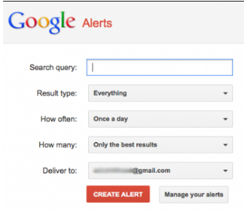

# Family History Nuggets

Do Genealogy While You Sleep!!

For help with your family history or questions call Jane Doe (Ward History consultant) at 801-867-9365.

If you would like to receive these FH Nuggets through email, send a request to janedoe@gmail.com

# Family History Nuggets

Have an ancestor that you can’t find? Trying to find a Family Bible? Create a google alert. Type in **“Google alert set up”** Enter the **search terms** you want Google to track separated by commas. Choose type of **results** ( I would start with “everything”) You can edit it later. Choose **how often** you want to be notified, Choose **how many results** you want to get (only the best results, or everything) Choose **where** you want them **delivered** (Such as your email address)

 Besides Google Alerts, put your tree in FamilySearch, Ancestry, MyHeritage, FindMyPast and others. Most all of them will find hints for your ancestors. They all use different search engines so results can vary.

Have an ancestor that you can’t find? Trying to find a Family Bible? Create a google alert. Type in **“Google alert set up”** Enter the **search terms** you want Google to track separated by commas. Choose type of **results** ( I would start with “everything”) You can edit it later. Choose **how often** you want to be notified, Choose **how many results** you want to get (only the best results, or everything) Choose **where** you want them **delivered** (Such as your email address)

Besides Google Alerts, put your tree in FamilySearch, Ancestry, MyHeritage, FindMyPast and others. Most all of them will find hints for your ancestors. They all use different search engines so results can vary.

For help with your family history or questions call Jane Doe (Ward History consultant) at 801-867-9365.

If you would like to receive these FH Nuggets through email, send a request to janedoe@gmail.com

Do Genealogy While You Sleep!!