What’s Descendancy Research?

What’s Descendancy Research?

For help with your family history or questions call Jane Doe (Ward History consultant) at 801-867-9365.

If you would like to receive these FH Nuggets through email, send a request to janedoe@gmail.com

1

4

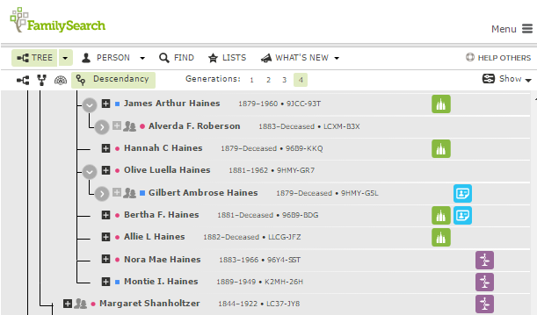

3

5

2

5

4

3

1

2

A Descendant is anyone born after (children grandchildren etc. Often referred to as cousins when trying to find our genealogy. We can do temple work for all our cousins & their families.

Go to familysearch.org and sign in with your user name and password. In Tree view choose the name of an ancestor born in the **late 1700’s**, click under his name to bring up a summary box

**1**- Then click on ”Tree”

**2**-Click on Descendancy icon

**3**-Click on 4 generations

**4**-Look for green squares with temples (need ordinances) yellow squares (need more information) Under “show” uncheck portraits.

**5**-No Marriage Icon? Look for spouses.



A Descendant is anyone born after (children grandchildren etc. Often referred to as cousins when trying to find our genealogy. We can do temple work for all our cousins & their families.

Go to familysearch.org and sign in with your user name and password. In Tree view choose the name of an ancestor born in the **late 1700’s**, click under his name to bring up a summary box

**1**- Then click on ”Tree”

**2**-Click on Descendancy icon

**3**-Click on 4 generations

**4**-Look for green squares with temples (need ordinances) yellow squares (need more information) Under “show” uncheck portraits.

5-No Marriage Icon? Look for spouses.

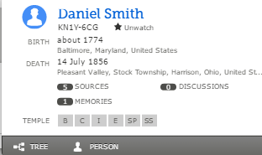

For help with your family history or questions call Jane Doe (Ward History consultant) at 801-867-9365.

If you would like to receive these FH Nuggets through email, send a request to janedoe@gmail.com

# Family History Nuggets

# Family History Nuggets

Fan Chart Full? Find More Ancestors!