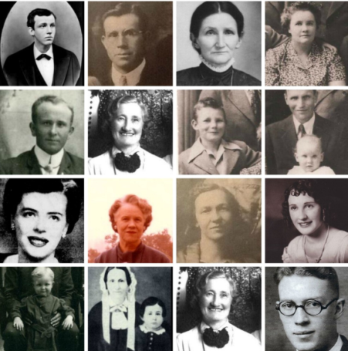

For help with your family history or questions call Jane Doe 801-123-4567

For help with your family history or questions Jane Doe 801-123-4567

This Thanksgiving when families are together and remembering their many blessings, think about and include your ancestors. Without them, we wouldn’t be here to even celebrate Thanksgiving! So here are a few ideas of ways you could incorporate your ancestors into your family gatherings. Go to FamilySearch.org to find pictures of your ancestors or a file in your computer. Use the “snippng tool” on your computer or download the pictures, or right click on a picture and do a “save as”. Get creative and maybe enlist your older children to help. Display pictures in with your table decorations, mod podge them onto candles or make place cards or napkin rings. Craft stores sell products that can transfer

This Thanksgiving when families are together and remembering their many blessings, think about and include your ancestors. Without them, we wouldn’t be here to even celebrate Thanksgiving! So here are a few ideas of ways you could incorporate your ancestors into your family gatherings. Go to FamilySearch.org to find pictures of your ancestors or a file in your computer. Use the “snippng tool” on your computer or download the pictures, or right click on a picture and do a “save as”. Get creative and maybe enlist your older children to help. Display pictures in with your table decorations, mod podge them onto candles or make place cards or napkin rings. Craft stores sell products that can transfer

Grateful for our Ancestors

paper pictures onto cloth, such as a table cloth, for a more permanent keepsake. A fun interactive game is Bingo. Google : http://www.keepmovingforwardwithme.com/bingo for instructions on how to do this. Be sure to include a name and fact with each face. Laminate. Glue pictures onto a paper table cloth and have family members write a caption with each picture or tell what they remember about them or why they are thankful for them. Maybe even fix a recipe that was passed down thru your family. These projects can be quick and simple or as involved as your time and energy allow. Keep it fun! Have a wonderful Thanksgiving!!!

# Family History Nuggets

# Family History Nuggets

paper pictures onto cloth, such as a table cloth, for a more permanent keepsake. A fun interactive game is Bingo. Google : http://www.keepmovingforwardwithme.com/bingo for instructions on how to do this. Be sure to include a name and fact with each face. Laminate. Glue pictures onto a paper table cloth and have family members write a caption with each picture or tell what they remember about them or why they are thankful for them. Maybe even fix a recipe that was passed down thru your family. These projects can be quick and simple or as involved as your time and energy allow. Keep it fun! Have a wonderful Thanksgiving!!!

Grateful for our Ancestors